Project Proposal

- Layout:
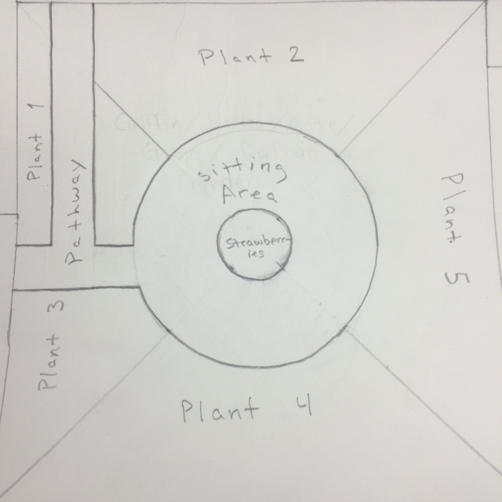
- Plants:
  - 15 Pacific Coast Iris(not sure)
  - California Poppy(seeds)
  - 4 California Strawberries
  - 15 Baby Blue Eyes(not sure)
  - 5 Sea Thrift
  - Lunaria (seeds)
- Interactions:
  - Bees & Plants
- Yes, our soil needs to be amended to support growth, through sheet mulching.

