Field Study
Site Introduction

By Jessica Walters ⅚

Site Description

Objective:
Study changes that happen overtime in nature. Observe relationships between animals. Analyze the environment as well as the plants and animals that live there.

Wednesday, 29 April 2015
- some sunlight, about half shaded by nearby trees
- creek, depth varies between ankle-deep and knee-deep, mostly slow moving, faster at the end of my area
- long pond, looks like it used to be connected to the creek, but isn’t anymore
- dragonflies, spiders, water striders, mosquitoes, bees, flies, butterflies, cicadas
- woodpeckers, scrub jays, wrens
- tadpoles and fish in the creek, squirrels, lizards
- gravel between creek and long pond
- plants on banks, blackberry, stinging nettle, poison oak, trees

Prediction:
I predict that as the weather gets warmer the water level in the creek will go down. I think the water temperature will increase in relation to the average air temperature. I also think there will be more bugs looking for water near the creek. I predict that the tadpoles I saw I the creek will eventually grow into frogs.

Site Overview

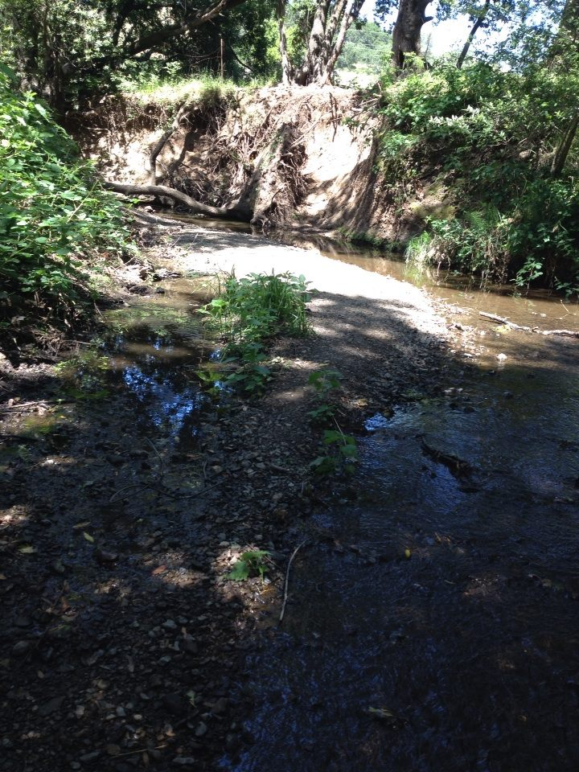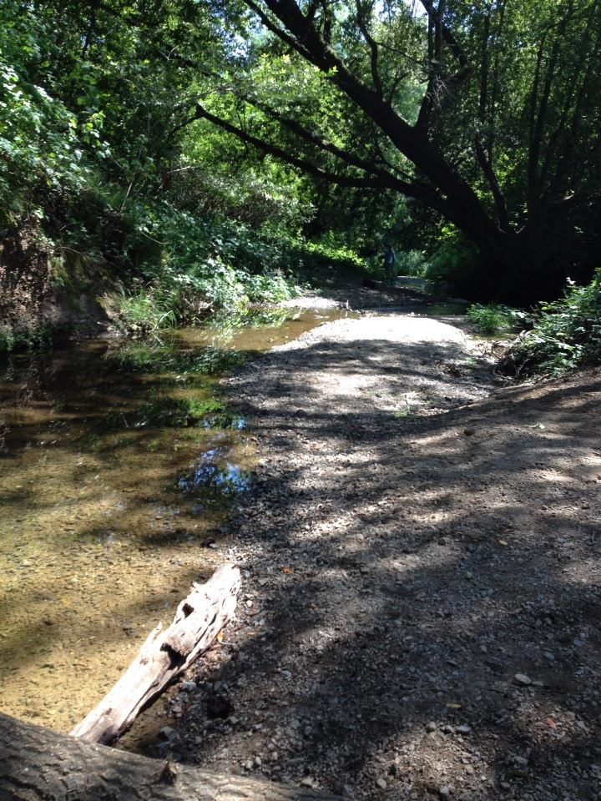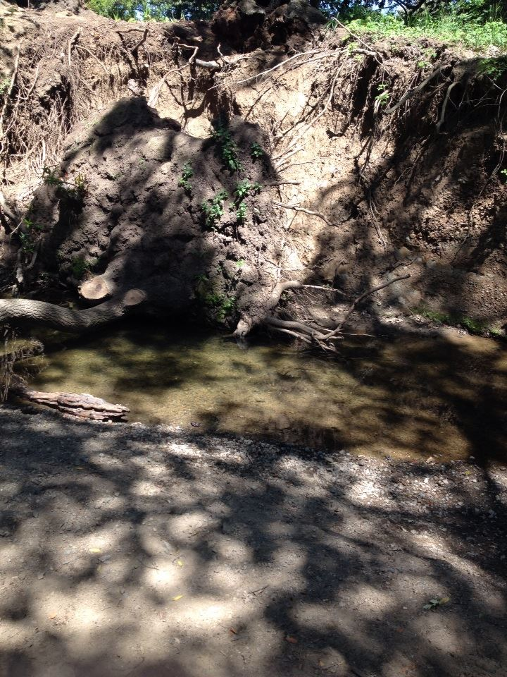
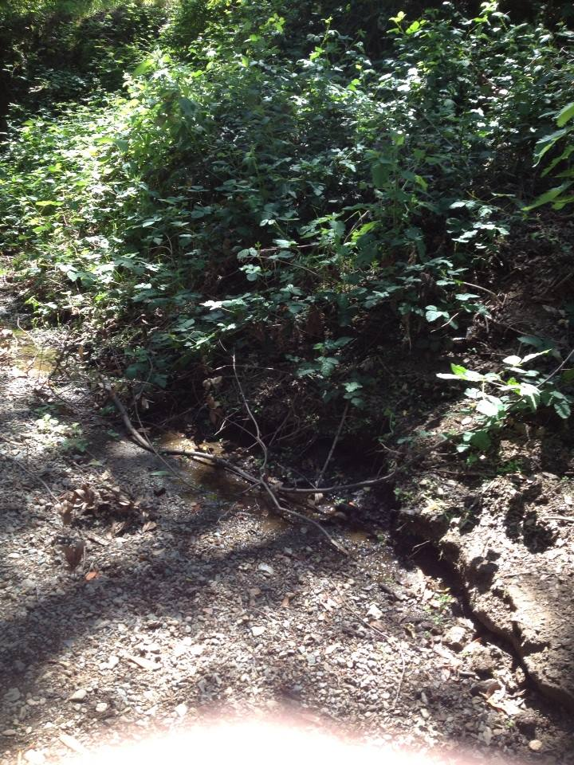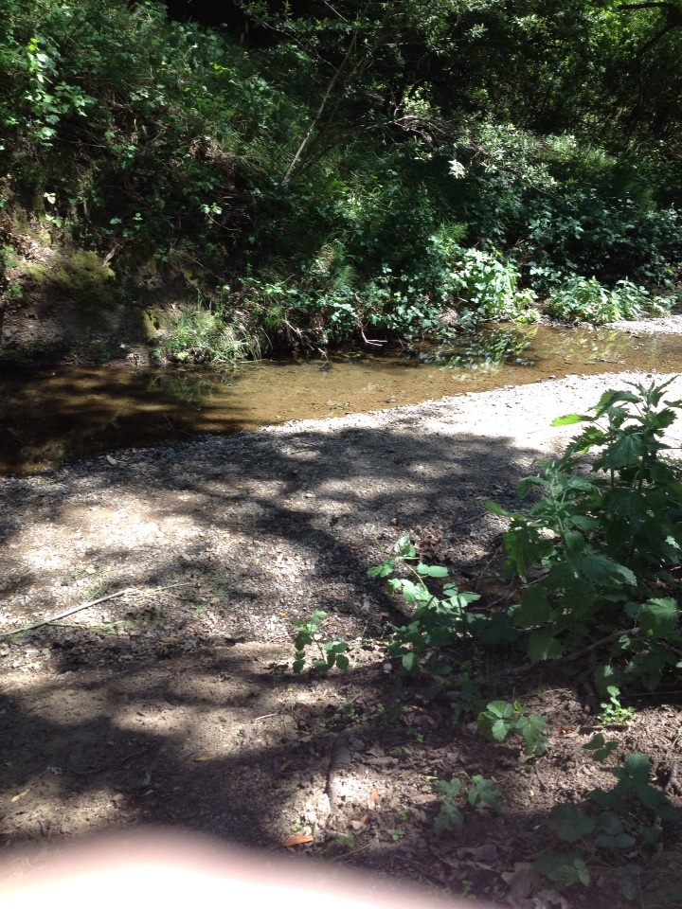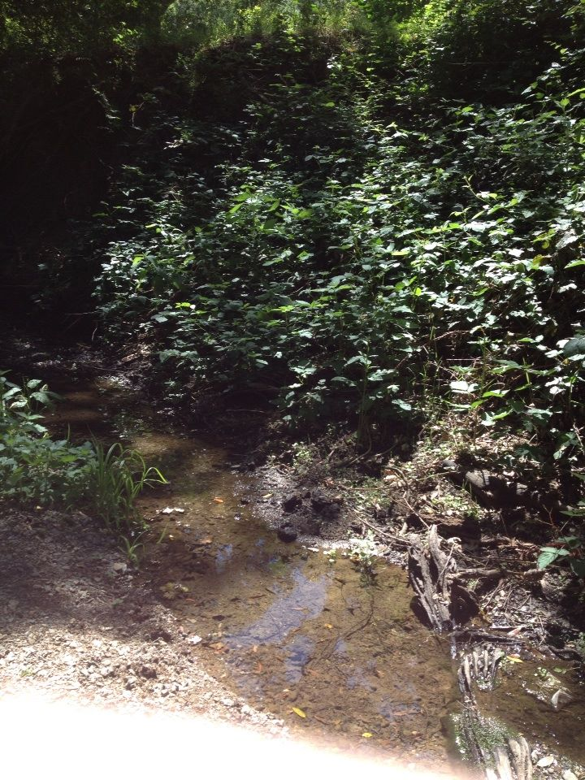

Site Data:

Biotic Data:
Measurement | Data
# of water striders | 3
# of mosquitoes | 4
# of bees | 2
# of flies | 1
# of butterflies | 1
# of cicadas | 1
# of dragonflies | 4
# of spiders | 1
# of tadpoles | 15
# of fish | 3
length of fish | 2 inches
# of plants | around 20
# of trees | 3 in area, more just outside area
# of ripe blackberries | 0
# of blackberry blossoms | 25
# of lizards | 2
average plant height | 10 inches

Abiotic Data:
Measurement | Data
length of day (Wednesday, April 4) | 13:52
creek depth | ankle to knee depth
creek speed | mostly slow except at end
length of long pond | 10 yards
temperature of creek | chilly
% of shade | 50%
% of dry ground covered by plants | 40%

